ASSIGNMENT

NM ID: 7D961AA44C2955C9A0F4402D3E61AD04

NAME:RAMANA A

1.Website using wordpress

Link: <https://mysports468.wordpress.com/>

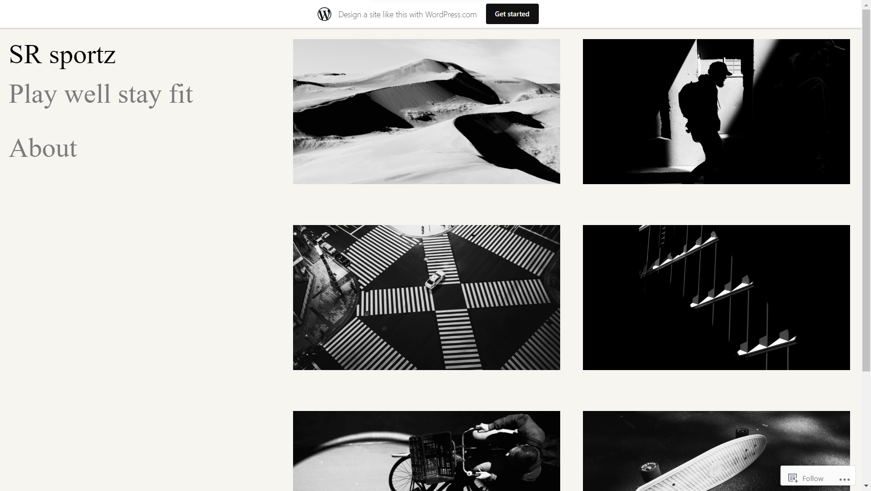

2.Create a new facebook business page and post one social media poster for your brand.

Link: <https://www.facebook.com/srsportz48?mibextid=ZbWKwL>

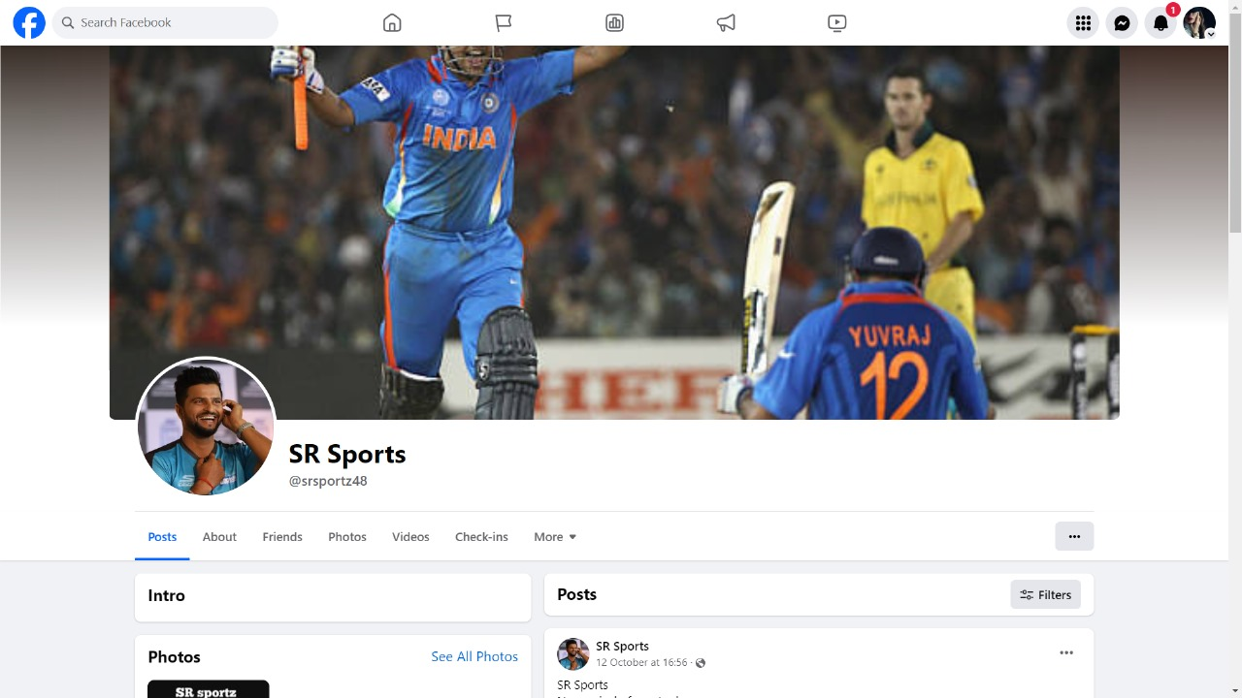

3.Create and design a social media advertisement poster using canva

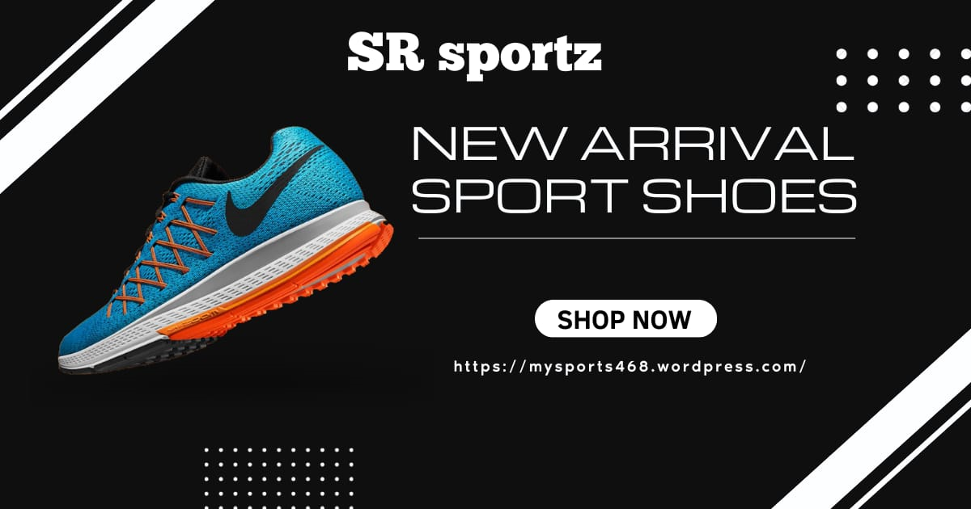

4.Create email newsletter design using mailchimp or canva tool.

